AI-Enabled Incident Demand Forecasting and Resource Dispatch Optimization in Municipal Emergency Response (ERP-Integrated): A 2024 911 Serviced Calls Case Study

Abstract

Municipal emergency response systems operate under continuous time pressure, uneven spatial demand, and limited operational resources. Despite having digital call records, dispatch, and resource allocation decisions often remain reactive, fragmented, and insufficiently data-driven. This case study explores how an AI-enabled decision-support framework can enhance municipal 911 operations by integrating baseline analytics, predictive modeling, prescriptive optimization, enterprise integration, and governance controls. Using a 2024 dataset of serviced 911 calls as the empirical foundation, the study establishes a descriptive and diagnostic baseline focused on demand patterns, response times, service-level performance, and precinct-level variations. Building on this foundation, it proposes a layered framework that includes demand forecasting, SLA breach prediction, resource allocation support, ERP integration across workforce, fleet, procurement, and finance functions, and RPA-enabled workflow automation. Designed as an MBA AI-in-business case, it balances analytical depth with managerial practicality. It offers a structured, operationally grounded model to shift municipal emergency response from reactive dispatch to accountable, data-supported decision-making, while explicitly addressing privacy, fairness, security, and implementation challenges. The design also aligns with established AI risk management and data protection principles, emphasizing trustworthy, governable, and risk-aware AI adoption in operational settings.

1. Introduction

1.1 Background

Municipal emergency response operations represent one of the clearest examples of real-time decision-making under uncertainty. Every incoming call creates an operational choice: how quickly to respond, which resource to assign, how to preserve coverage across zones, and how to manage service quality under fluctuating demand. These decisions are not only technical or procedural; they are managerial, because they directly affect organizational performance, public trust, cost efficiency, and accountability.

The increasing availability of digital operational data has created an opportunity to improve these decisions. Modern call-service datasets preserve far more than historical records of incidents. They capture temporal patterns, geographic concentration, call categories, process timing, and performance variation across operational areas. In principle, these data can support descriptive insight, predictive awareness, and prescriptive action. In practice, many emergency response organizations still rely on reactive workflows and fragmented information environments.

1.2 Problem

The core challenge addressed in this study is that dispatch and resource allocation are often guided by immediate pressure rather than systematic foresight. When organizations operate this way, several problems emerge simultaneously: service-level breaches become concentrated during peak periods, some precincts or shifts experience disproportionate strain, costs rise through overtime and inefficient asset use, and decision rationales become difficult to audit. These problems are not necessarily caused by a lack of effort or commitment. Rather, they reflect a structural gap between the data available to the organization and the way that data is translated into action.

1.3 Motivation

This case study is motivated by the need to bridge that gap. From an MBA perspective, the case is not simply about applying machine learning to a public-sector dataset. It is about designing a decision-support capability that aligns analytics, operational workflows, enterprise systems, automation, and governance into a coherent business solution. That is what makes the case strategically relevant: the objective is not prediction for its own sake, but improved operational performance, more transparent managerial control, and stronger institutional resilience.

A second motivation lies in the growing importance of responsible AI adoption in enterprise settings. NIST’s AI Risk Management Framework is explicit that AI systems should be designed and deployed in ways that improve trustworthiness and manage risks to individuals, organizations, and society. The framework is voluntary, use-case-agnostic, and intended to be practical across sectors, making it directly relevant to public-service operations such as emergency response.

1.4 Contributions of This Study

This study makes four main contributions. First, it uses a real municipal 911 service calls dataset as the basis for a structured descriptive and diagnostic analysis of operational performance. Second, it proposes a layered AI-enabled framework that links demand forecasting, breach-risk prediction, and dispatch-oriented optimization to business and operational decision-making. Third, it embeds that framework in an enterprise integration logic by connecting it to ERP-relevant functions such as workforce planning, fleet readiness, procurement, and financial control, alongside RPA-enabled workflow automation. Fourth, it places the proposed system within a governance-aware perspective that considers privacy, fairness, security, and implementation limitations as part of the design rather than as afterthoughts.

2. Industry / Business Context and Related Background

Municipal emergency response is a high-velocity service environment in which operational quality depends on the ability to convert incomplete, fast-moving information into timely and defensible action. Unlike purely administrative workflows, emergency operations are shaped by temporal concentration, geographic unevenness, and hard capacity constraints. A system may perform adequately under average conditions but still fail during surges, shift transitions, or localized demand concentrations. This makes performance management more complex than simply reducing average response time. It requires an understanding of where pressure accumulates, why certain zones underperform, and how resource allocation interacts with real operating constraints.

From a managerial standpoint, this environment resembles other resource-constrained service systems, but with more severe consequences for inconsistency. Poorly balanced dispatch decisions can produce delayed response, uneven service coverage, and rising operating costs. They can also weaken confidence in management’s ability to explain how resources are being allocated and why service outcomes differ across operational areas. For this reason, emergency response provides a strong case for AI-enabled decision support: it contains measurable performance indicators, large volumes of operational data, repetitive but high-stakes decision patterns, and clear opportunities for workflow redesign.

The broader enterprise AI literature also supports treating this case as more than a narrow technical exercise. AI adoption in operational settings increasingly intersects with enterprise systems, workflow automation, and governance concerns related to compliance, monitoring, and risk management. NIST’s AI RMF emphasizes governability, measurement, and risk-aware deployment, while Microsoft’s field-service documentation shows how operational decision support becomes more useful when linked to scheduling, inventory, purchasing, and financial processes.

This business context also aligns directly with the managerial logic of digital transformation. Microsoft’s Field Service materials consistently frame field operations as a connected system that combines scheduling, dispatch, asset history, inventory, billing, and analytics. Although this case is not a product implementation report, the architecture is useful because it illustrates the same principle: prediction alone is not enough; insights must connect to people, assets, costs, and workflows to become operationally meaningful.

3. Problem Statement and Research Objective

3.1 Business Problem Definition

The central business problem in this case is the persistent gap between the volume and richness of operational emergency-response data and the quality of dispatch and resource-allocation decisions derived from it. Municipal 911 operations generate detailed records about call timing, location, category, priority, and response performance. However, these data do not automatically translate into better decisions. In many operational settings, dispatch remains largely reactive, with supervisors and dispatchers making choices under pressure using fragmented visibility into current load, historical trends, and emerging risk.

This gap produces several interrelated consequences. First, response performance becomes uneven across time periods and operating zones. Second, service-level breaches tend to cluster during pressure points rather than being evenly distributed. Third, resource use becomes less efficient, contributing to avoidable overtime, imbalanced workload, and unnecessary operational strain. Fourth, the organization’s ability to explain, review, and continuously improve decision quality is weakened because decision rationales are not systematically supported by a structured analytical layer.

3.2 Why Traditional Methods Are Insufficient

Traditional dispatch logic is not inherently irrational; it is often shaped by experience, urgency recognition, and local operational knowledge. The problem is that these strengths are not enough when incident demand fluctuates dynamically, and constraints interact across multiple layers. Manual decision-making struggles to maintain consistency when demand varies simultaneously by hour, day, zone, and incident type. It also struggles to account for cumulative pressure, such as rising backlog, uneven coverage, or shifting fleet and staffing capacity.

As a result, traditional methods tend to be strong at immediate reaction but weak at anticipatory allocation. They answer the question “What should I do right now?” more readily than “What is likely to happen next, and how should resources be positioned in advance?” This distinction is critical. Once the system is already overloaded, even good dispatch judgment operates from a degraded starting point. A more mature operating model requires foresight, structured prioritization, and a transparent link between operational data and action.

3.3 Research Objective

The objective of this case study is to design and justify an AI-enabled decision-support framework for municipal emergency response that improves the quality, consistency, and transparency of dispatch-oriented decision-making. More specifically, the study aims to:
- establish an empirical baseline of operational performance using a 2024 serviced 911 calls dataset;
- identify temporal, spatial, and categorical patterns associated with demand concentration and response degradation;
- propose a layered architecture that combines descriptive analytics, diagnostic insight, predictive modeling, and prescriptive optimization;
- show how this architecture can be operationalized through ERP integration and RPA-supported workflows; and
- Evaluate the expected managerial and operational value of such a system while explicitly addressing governance, privacy, fairness, security, and implementation constraints.

The study does not claim to present a fully deployed municipal platform. Rather, it develops a structured, credible, and submission-quality case that bridges empirical analysis with a realistic transformation design.

4. Data and Analytics Foundation

4.1 Dataset Overview

The empirical base of this study is the Police_Serviced_911_Calls_2024.csv dataset, which contains 324,871 records and 26 columns covering serviced emergency-response events over the course of 2024. The dataset includes timestamps, priority indicators, spatial attributes, call categories, descriptive text fields, and multiple time-related variables associated with the service lifecycle. These fields make it suitable for descriptive analysis, diagnostic decomposition, and the design of downstream predictive and prescriptive models.

The dataset is particularly useful for this case because it is operational rather than synthetic. It does not merely describe hypothetical incidents; it captures real workload patterns and response dynamics over a full annual cycle. This gives the study a stronger empirical foundation than a purely simulated case and allows the analytical framework to be grounded in genuine operational variance.

4.2 Key Variables and Operational Meaning

Several fields have direct analytical relevance:
- called_at: call timestamp, used to derive hourly, daily, monthly, and shift-based demand patterns.
- Priority: an urgency-related field used to structure SLA logic and breach measurement.
- precinct: an operational-area variable used to compare spatial performance and demand concentration.
- category and call_description: incident classification fields used to identify workload composition and stress patterns.
- total_response_time: the principal service-performance measure in the current case.
- intake_time, dispatch_time, travel_time, on_scene_time: component measures that support decomposition of the response chain.
- Longitude/latitude and related area fields: spatial attributes that can support zone mapping and future spatial refinement.

4.3 Data Quality, Assumptions, and Treatment Logic

The dataset is treated as the primary empirical source for baseline analysis, but it still requires structured handling. The analysis assumes that timestamps are standardized appropriately for analytical grouping and that response-time variables are numerically interpretable in minutes. Where priority values are inconsistent, missing, or operationally ambiguous, conservative treatment rules are applied so that performance classification remains transparent rather than artificially precise.

Missing values are not treated as a minor technical issue but as an operational data-governance concern. The handling logic distinguishes between variables essential for KPI construction and variables that are supplementary. Records missing the core performance field used to compute service-level status would be excluded from those calculations, while still potentially remaining useful for broader demand analysis if their timing and category fields remain intact.

The analytical posture of this study is deliberately cautious. Dataset-supported findings are presented as findings. Proposed model outputs are treated as design logic until executed. Cost and ERP-related values that do not exist in the raw dataset are explicitly treated as simulated or assumed parameters for business analysis.

4.4 KPI Framework and SLA Logic

To anchor the case empirically, the study defines a baseline KPI framework around service performance, demand concentration, and process decomposition. The main indicators include:
- median total response time;
- upper-tail response time behavior (P90);
- SLA compliance rate overall;
- SLA compliance by priority;
- breach concentration by precinct and shift;
- demand by hour, day of week, and month; and
- response-time decomposition across intake, dispatch, travel, and on-scene stages.

The case uses a priority-sensitive SLA logic rather than a single flat threshold. Service thresholds were derived from the 75th percentile of observed response performance by priority and then rounded into operationally readable targets. The resulting thresholds were: Priority 1 = 15 minutes, Priority 2 = 40 minutes, Priority 3 = 75 minutes, Priority 4 = 120 minutes, Priority 5 = 80 minutes, Unknown = 120 minutes. This is a transparent case-study assumption, not a claim about an official municipal SLA policy.

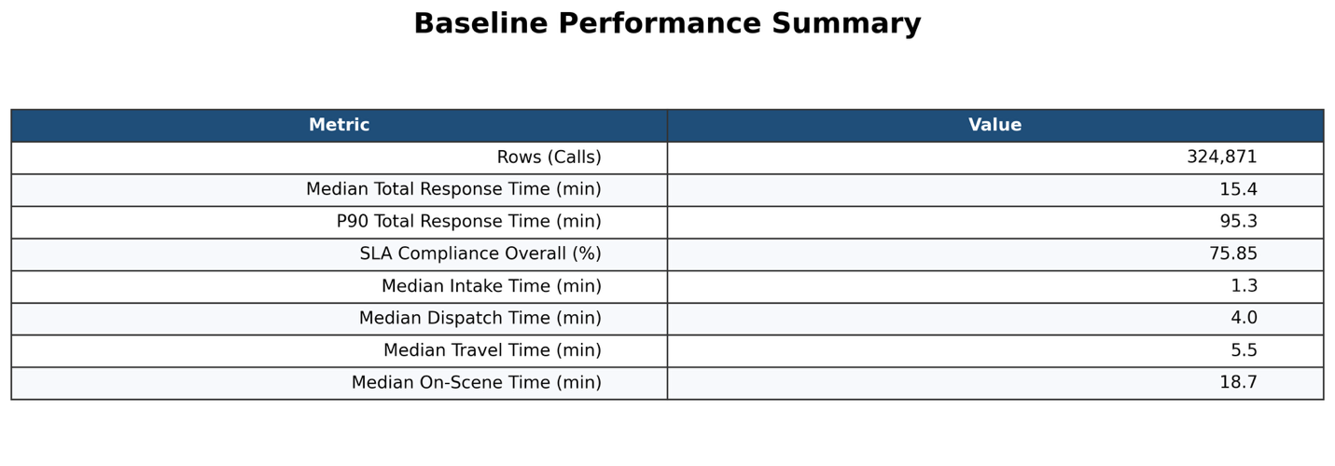
Figure 1. Baseline performance summary for the 2024 serviced 911 calls dataset.

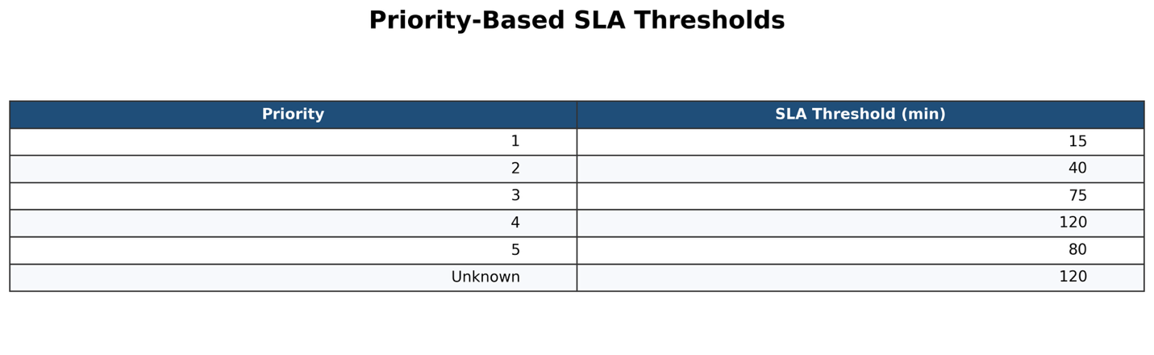
Figure 2. Priority-based SLA thresholds derived from the dataset’s P75 response-time distribution.

Baseline findings from the KPI summary were as follows:
- total calls analyzed: 324,871
- median total response time: 15.4 minutes
- P90 total response time: 95.3 minutes
- Overall SLA compliance: 75.85%
- median intake time: 1.3 minutes
- median dispatch time: 4.0 minutes
- median travel time: 5.5 minutes
- median on-scene time: 18.7 minutes

4.5 Descriptive and Diagnostic Analytics

The first analytical layer of the study is descriptive and diagnostic. Its purpose is not yet to optimize or predict, but to establish the shape of the operational problem.

The generated outputs show several useful patterns. Hourly demand is clearly uneven, dropping to its lowest level around early morning and then climbing steadily toward a late-afternoon and early-evening peak. The strongest visible peak appears around 16:00–17:00, after which volume remains elevated before tapering later in the evening. This alone provides a strong operational rationale for demand forecasting, because the system does not face a uniform workload. Monthly demand also varies meaningfully, rising from winter into late spring and peaking around July, before gradually declining toward year-end. Daily demand is more stable than hourly demand, but weekends still appear slightly higher than mid-week, with Saturday as the highest-volume day in the current baseline.

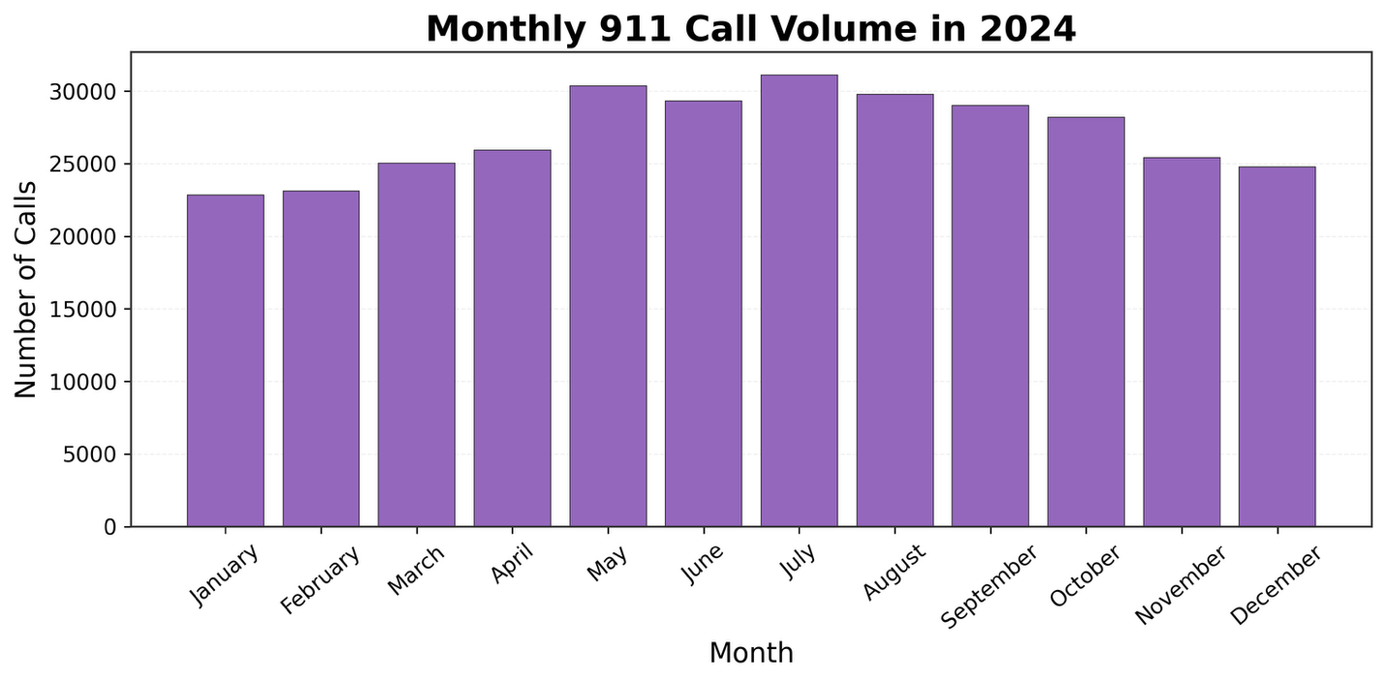
Figure 3. Monthly 911 call volume in 2024.

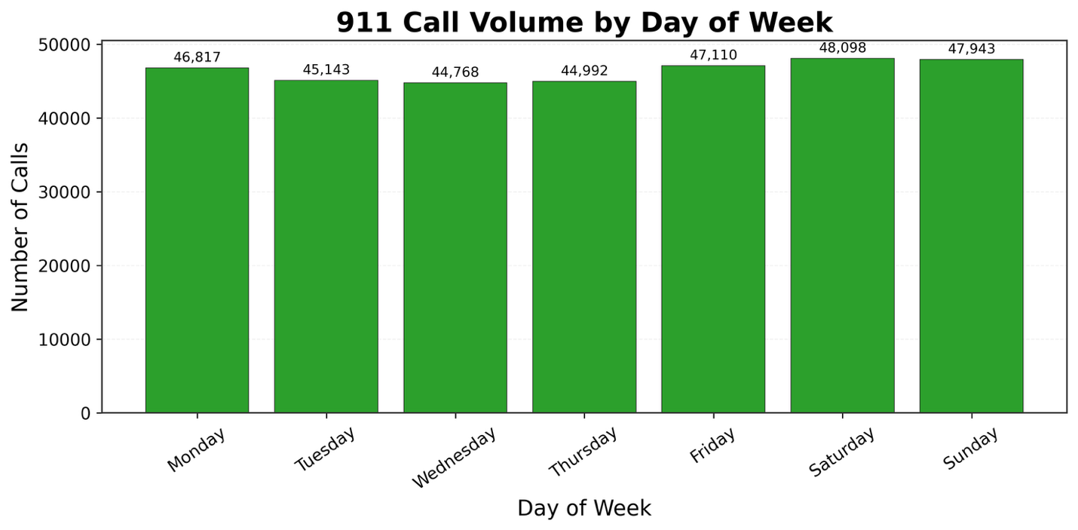
Figure 4. 911 call volume by day of week.

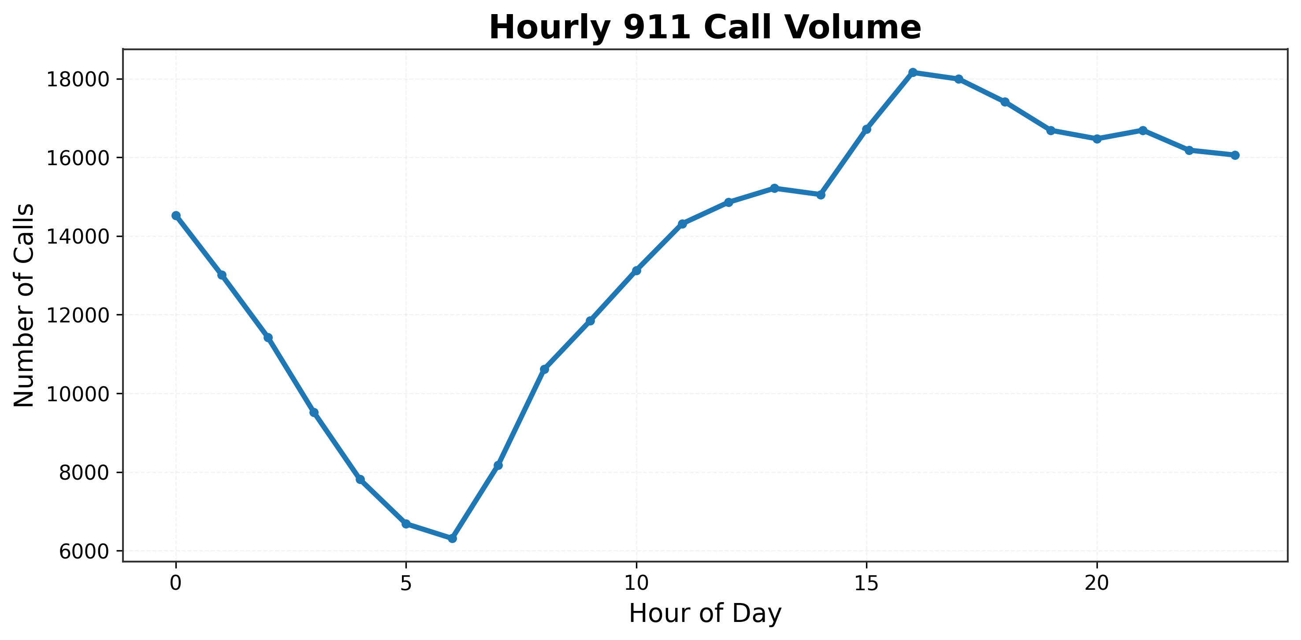
Figure 5. Hourly 911 call volume showing clear late-afternoon demand concentration.

The spatial dimension is equally important. The demand heatmap shows that the evening shift consistently carries the highest call volume across most precincts. Precinct 8 has the highest observed demand concentration, especially in the evening, followed by precincts 9, 12, and 3. This indicates that the core managerial problem is not simply “too many calls overall,” but “when and where call pressure accumulates.” The breach heatmap reinforces this point. SLA breach rates are not evenly distributed. Some precinct–shift combinations perform relatively well, while others show notably elevated breach rates, especially in the evening and night shifts. The most severe observed breach concentrations are in Unknown–Evening (37.3%), Precinct 6–Evening (36.0%), and Precinct 8–Night (35.2%). By contrast, Precinct 3–Day (7.4%) performs comparatively well. These differences suggest that operational pressure is uneven and therefore a strong candidate for targeted AI-assisted intervention.

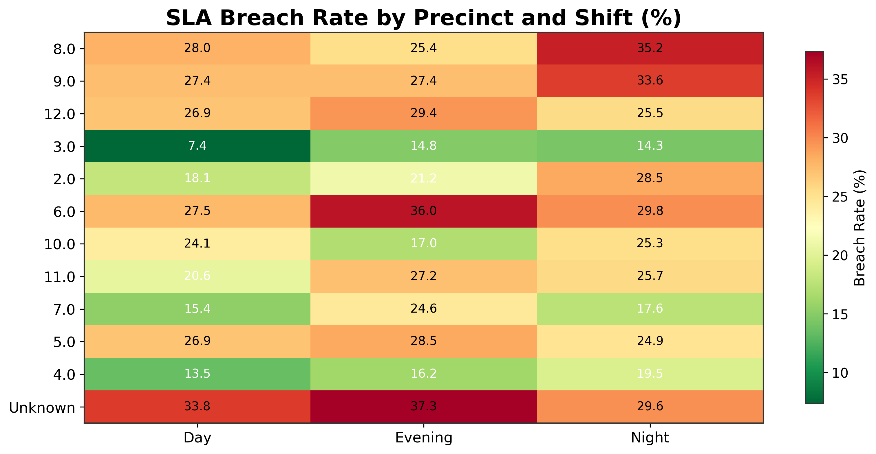

Figure 6. SLA breach rate by precinct and shift.

The category analysis also matters. A relatively small number of incident categories account for a large share of the total workload. The largest category by volume is DISTURB (67,443 calls), followed by UNKPROB (31,608), FA IP (18,242), AB IP/JH (14,160), and DV A/B (13,507). By contrast, the top categories by breach rate tell a slightly different story: MISSSER, HI2JH, PPOIP, and HI2IP each show breach rates close to or above the high-30% range. This distinction is analytically important. Some incident types dominate workload; others dominate service risk.

Finally, the decomposition chart shows where time is being spent within the response chain. The median on-scene time (18.7 minutes) is by far the largest component, followed by travel time (5.5 minutes), dispatch time (4.0 minutes), and intake time (1.3 minutes). This is a useful managerial finding because it suggests that performance pressure is not driven only by call-taking or dispatch processing. The field side of the response chain, especially on-scene duration, is a major contributor to total service time.
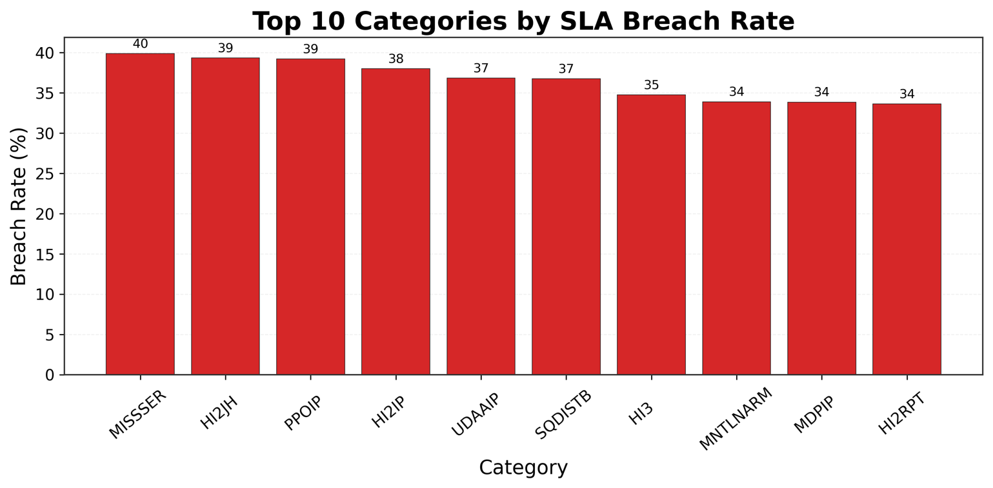

Figure 7. Top 10 incident categories by call volume.
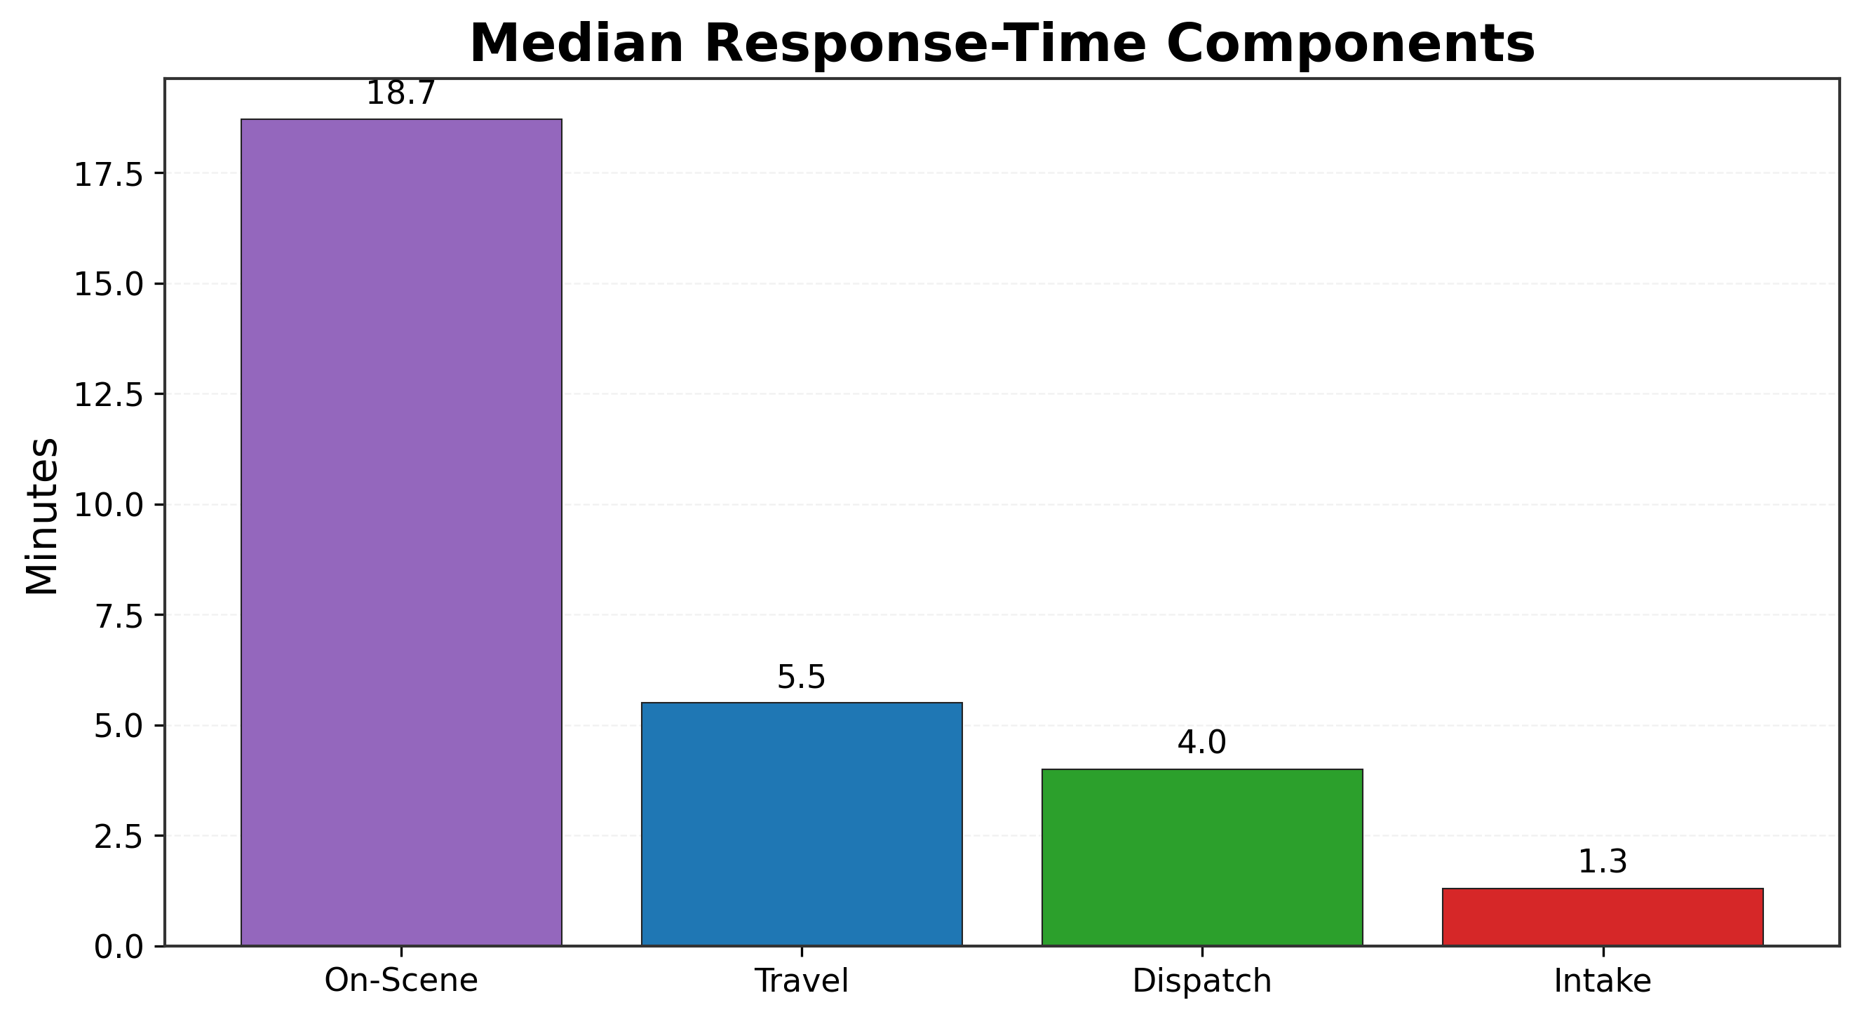
Figure 8. Median response-time components across the service chain.

5. Proposed AI-Enabled Framework / Methodology

5.1 Conceptual Architecture

The proposed framework is organized as a layered architecture that moves from data capture to analysis, prediction, prescription, execution, and governance. This design is intentional. It reflects the principle that AI in enterprise operations should not be treated as an isolated model but as part of a broader decision and workflow ecosystem.

At a high level, the architecture consists of:
- a descriptive and diagnostic analytics layer;
- a predictive layer for demand and breach risk;
- a prescriptive layer for allocation and dispatch support;
- an ERP integration layer;
- an RPA workflow layer; and
- a governance and control layer.

[Insert Figure 11 here: Overall AI-Enabled Framework / Architecture — create as diagram]

5.2 Descriptive and Diagnostic Layer

The first layer establishes operational visibility. It answers questions such as:
- When do calls surge?
- Which precincts experience heavier demand?
- Where do breach rates concentrate?
- Which component of the response chain contributes most to delay?

This layer is foundational because it translates raw records into managerial visibility. It also helps ensure that later models are solving real bottlenecks rather than abstract optimization problems disconnected from the actual operating environment.

5.3 Predictive Layer

The predictive layer contains two main components:

Demand forecasting, which estimates incident volume by zone and shift; and
breach-risk prediction, which estimates the probability that a call or operating cell will exceed the relevant service threshold.

The purpose of the demand model is anticipatory positioning. The purpose of the breach model is selective attention. Together, they shift the system from simple historical reporting toward forward-looking operational readiness.

This design choice is supported by current emergency-services literature. Recent machine-learning work on EMS response times and EMS demand prediction has shown that urgency, temporal patterns, environmental variables, and geographic features can materially improve operational forecasting and planning.

5.4 Prescriptive Layer

Prediction alone does not allocate resources. The prescriptive layer is designed to translate forecasted demand and breach risk into feasible allocation recommendations. This may include prioritizing specific zones for additional resource positioning, recommending shift-level redistribution, or highlighting situations where coverage risk is likely to rise unless corrective action is taken.

The emphasis here is on feasible optimization, not abstract perfection. A municipal operations center functions under constraints, including staffing, fleet readiness, procedural rules, and uneven geography. The role of prescriptive logic is therefore to support better decisions within constraints rather than to eliminate operational uncertainty.

5.5 ERP Integration Layer

A key feature of this case is that it does not treat AI as a detached analytics product. Instead, it places the decision-support framework in relation to enterprise resource functions, especially:
- HR/workforce for shift planning and staff capacity;
- fleet/assets for readiness and availability;
- procurement/inventory for replenishment and support workflows; and
- finance for cost visibility and ROI logic.

This matters because the downstream value of prediction depends on whether the organization can act on it through its resource and workflow systems. Microsoft’s field-service documentation is useful here as an enterprise analogy: it shows that service operations improve when scheduling, asset history, inventory, procurement, and financial processes are connected instead of isolated.

5.6 RPA Workflow Layer

RPA is included not as an intelligence layer but as an execution-support layer. Its role is to automate repetitive, rule-based tasks once decisions or alerts are generated. Examples include:
- creation of SLA exception reports;
- automated routing of management summaries;
- generation of maintenance or replenishment triggers; and
- workflow notifications tied to threshold events.

Microsoft’s RPA guidance describes this kind of use case clearly: bots are not used to “think” strategically, but to trigger responses, manipulate data, and automate repetitive enterprise tasks at scale.

5.7 Governance and Control Layer

The final layer recognizes that operational AI must be governable. This includes access control, audit logging, bias monitoring, model documentation, decision traceability, and human oversight. In emergency-response settings, this layer is especially important because recommendations affect real-time service prioritization and can influence equity across zones.

NIST’s AI RMF explicitly frames trustworthy AI as something that must be governed across the system lifecycle, not simply tested at the end. Similarly, ISO/IEC 27001 emphasizes a risk-managed information-security approach, while the European Commission’s GDPR guidance highlights lawfulness, fairness, transparency, purpose limitation, data minimisation, accuracy, storage limitation, integrity/confidentiality, and accountability as core principles of responsible processing.

6. Algorithms and Technical Implementation

6.1 Descriptive and Diagnostic Methods

The current case uses a series of classical analytical methods before introducing machine learning. These include:
- aggregation by time bucket and precinct;
- percentile-based performance analysis;
- service-threshold comparisons;
- heatmap visualization; and
- component decomposition of response time.

These methods are simple, transparent, and highly suitable for baseline diagnosis. Their value lies in clarity rather than computational novelty. For an MBA case study, that is a strength: they make the logic of the operational problem visible before more advanced methods are introduced.

6.2 Predictive Algorithms

6.2.1 Demand Forecasting
Demand forecasting may be approached using time-series and supervised machine-learning models, depending on the granularity of the prediction target. Suitable candidate methods include:
- moving-average or seasonal baseline forecasting;
- gradient-boosted tree models for structured tabular forecasting;
- random forest regressors where nonlinear interactions are expected; and
- other time-aware supervised methods as appropriate to the final data-preparation stage.

The preferred modeling strategy should start with a transparent baseline and then progress to stronger models only if they demonstrate meaningful improvement. Recent emergency-care and EMS forecasting work supports this staged logic, especially when calendar, environmental, and engineered features materially influence demand patterns.

6.2.2 SLA Breach Prediction
Breach prediction is framed as a classification problem. Candidate methods include:
- logistic regression as an interpretable baseline;
- decision trees and random forests for nonlinear classification; and
- gradient boosting for higher predictive sensitivity when needed.

Inputs may include priority, time-of-day, day-of-week, precinct, category, and rolling demand indicators. Output is a breach-risk score or label that supports operational awareness.

6.3 Prescriptive / Optimization Logic

The prescriptive layer is not aimed at replacing dispatchers. It is aimed at supporting allocation under constraints. The optimization problem can be framed as minimizing expected service breaches and resource strain subject to:
- available capacity by shift and area;
- minimum coverage requirements;
- asset availability; and
- workload or overtime limits.

In practical terms, this can be approached as a constrained optimization or rule-based prioritization engine, depending on the maturity of the case at submission time.

6.4 Source Code and Implementation Workflow

The implementation workflow for this case is designed in Python, using widely adopted data and visualization libraries. The descriptive and diagnostic layer is implemented through scripts that:
- load and clean the CSV dataset;
- standardize relevant fields;
- compute KPI baselines;
- derive SLA logic and breach flags;
- generate trend charts, heatmaps, and decomposition figures; and
- export tables and visuals for direct integration into the report and presentation.

Typical tools and libraries include:
- pandas for data manipulation;
- numpy for numerical operations; and
- matplotlib for chart generation.

If predictive or optimization code is executed later in the project, it should be documented under the same implementation section, with model-specific preprocessing, training, and output-generation logic described clearly.

6.5 Degree of Execution

At the current stage, the case is best described as partially executed and partially designed. The descriptive and diagnostic foundation is executed and directly tied to the dataset. The predictive and prescriptive components are structurally defined and technically plausible, but some may remain at prototype or design level depending on the timing of full model execution and validation.

This distinction should be made explicit in the paper. It strengthens credibility rather than weakening it.

6.6 Code Placement and Documentation

The main article should explain the code logic, the purpose of each script, and the outputs produced. Full source code, however, should be placed outside the main body if it becomes too long. Appropriate locations include:
- an appendix to the report;
- an annex; or
- a referenced repository if permitted by the submission format.

The article should summarize, for example, that one script generated KPI baselines and heatmaps, while another script is intended to support model training or scenario evaluation.

7. Digital Transformation and Enterprise Integration

7.1 Before vs After Operating Model

Before transformation, municipal emergency response in this case is characterized by reactive coordination, fragmented analytical visibility, and manual performance interpretation. Data exists, but it is not fully converted into forward-looking decisions. Supervisors respond to current pressure rather than managing anticipated pressure. Reporting is retrospective, and operational strain appears in the form of clustered service breaches, inconsistent zone performance, and limited decision traceability.

After transformation, the proposed model introduces a more mature operating logic. Demand signals become anticipatory rather than purely historical. Breach risks become visible before they fully materialize. Allocation decisions are supported by structured recommendations rather than relying solely on pressure-based judgment. Enterprise systems become part of the response logic, and routine workflow execution is supported through automation.

[Insert Figure 12 here: Before vs After Operating Model — create as comparison diagram]

7.2 Workflow Transformation

The core workflow changes in three ways.

First, information timing changes: instead of only knowing what has happened, managers see what is likely to happen next.
Second, decision quality changes: recommendations become more systematic and auditable.
Third, execution speed changes: repetitive reporting and threshold-driven workflows can be automated.

This is a digital transformation not because it introduces technology, but because it changes the way decisions are made, justified, and operationalized.

7.3 ERP Role in Institutionalization

ERP integration gives the proposed system institutional depth. Workforce availability, fleet readiness, procurement triggers, and finance controls are not peripheral to emergency response; they are part of its operating capacity. By linking the analytical system to ERP-relevant modules, the case demonstrates how AI can become part of organizational infrastructure rather than a stand-alone dashboard exercise.

7.4 RPA Role in Execution

RPA supports execution where decisions translate into repeatable administrative or operational actions. In this case, it can support standardized reporting, threshold-triggered notifications, and workflow handoffs. Importantly, RPA is not presented as replacing judgment. It automates routine process steps while preserving human accountability over consequential decisions.

[Insert Figure 13 here: ERP + RPA Integration Flow — create as flowchart]

8. Case Application / Practical Use Scenario

To illustrate the practical use of the proposed system, consider a scenario in which call volume begins to rise across several precincts during a late-afternoon transition period. The descriptive analytics already show that hourly demand climbs steadily toward late afternoon, with one of the most visible peaks around 16:00–17:00. At the same time, the heatmaps indicate that the evening shift tends to concentrate both demand and breach pressure in several precincts.

In this scenario, the dashboard receives live or near-live incident updates and overlays them on forecasted demand pressure for the next shift block. The demand model identifies two precincts with expected above-baseline volume, while the breach-risk model flags a third precinct whose projected service pressure is higher than its raw call volume alone would suggest. That matters operationally, because it points management toward a coverage problem rather than simply a call-count problem.

The prescriptive layer then recommends a feasible redistribution of available units, taking into account coverage minimums, staffing constraints, and expected service pressure. A supervisor reviews the recommendation, approves the reallocation, and the workflow layer generates the corresponding notifications, reporting updates, and administrative follow-through. What improves in this scenario is not certainty, but quality of preparation. The organization is no longer reacting only after backlog accumulates. It is acting on structured early signals while maintaining a human approval process and a record of how decisions were made.

This scenario is intentionally realistic rather than idealized. It assumes operational constraints remain present, and it does not claim that the system eliminates delays. Instead, it demonstrates how analytical foresight and enterprise coordination can improve the quality of action under pressure.

9. Evaluation / Analytical Findings / Comparative Logic

9.1 Baseline Findings

At the current stage, the strongest empirical findings in this case come from the descriptive and diagnostic analytics layer. These findings include:
- median total response time of 15.4 minutes;
- a very high P90 of 95.3 minutes, indicating a substantially long-delay tail;
- 75.85% overall SLA compliance;
- strong hourly and monthly demand variation;
- clear concentration of demand in the evening shift across most precincts;
- non-uniform breach rates, with some precinct–shift cells materially worse than others; and
- a response-time decomposition showing that on-scene time is the largest median component.

These findings are analytically valuable even before predictive models are fully trained because they establish where the system is under pressure and which dimensions of the problem matter most.

9.2 Evaluation Logic for the Proposed System

Evaluation of the proposed framework should proceed in layers.

For the descriptive and diagnostic layer, success is measured by clarity, visibility, and management usefulness.
For the predictive layer, success is measured through forecasting or classification quality relative to transparent baselines.
For the prescriptive layer, success is measured through operational comparison logic, such as reduced expected breach concentration, better workload balance, or improved coverage consistency under simulated scenarios.

9.3 Baseline vs Proposed Comparison

The comparison logic in this paper is structured around a before-versus-proposed analysis:
- baseline operation: reactive, fragmented, reporting-heavy;
- proposed operation: anticipatory, layered, and workflow-integrated.

Where fully executed model outputs are not yet available, the paper should state that the baseline is empirical while the comparison to the future-state system is based on structured design logic and scenario evaluation. This preserves credibility.

9.4 Manual vs AI-Supported Comparison

A useful comparative lens is manual versus AI-supported decision-making. Manual dispatch is not treated as irrational or obsolete. It is treated as limited under scale, complexity, and time pressure. AI-supported dispatch, by contrast, is framed as:
- more anticipatory;
- more consistent in its use of historical and live signals;
- more transparent in how recommendations are formed; and
- more compatible with systematic monitoring and review.

The strongest version of this comparison is not “human versus machine,” but “experience alone versus experience supported by structured analytics.”

10. Business Impact and Value Creation

10.1 Operational Value

Operationally, the proposed framework offers value in four main areas:
- improved visibility into when and where pressure accumulates;
- better allocation support during surge conditions;
- reduced concentration of service-level breaches; and
- faster and more standardized reporting through workflow automation.

These outcomes are relevant to both frontline management and organizational oversight.

10.2 Strategic Value

Strategically, the framework supports stronger institutional control over service quality. It creates a basis for more defensible decisions, more transparent review, and better alignment between analytical capability and resource planning. In public-service settings, this matters because performance is not judged only by averages, but also by consistency, equity, and trust.

10.3 Cost / ROI Logic

Because the raw dataset does not directly include all enterprise cost fields, cost and ROI analysis in this case should be treated as parameterized rather than fully observed. That said, a credible managerial cost logic can still be developed around:
- overtime reduction;
- improved fleet utilization;
- lower manual reporting effort; and
- avoided escalation associated with clustered service breaches.

The paper should clearly label these calculations as assumption-based business analysis built on top of empirical operational findings.

10.4 Scalability and Sustainability

The proposed framework is scalable because it separates its layers cleanly. The descriptive analytics layer can deliver value even before advanced modeling is fully operational. Predictive and prescriptive capabilities can then be added incrementally. ERP integration and RPA support further enhance sustainability by embedding the solution within institutional workflows rather than leaving it as a one-off analytical project.

11. Risks, Ethics, Compliance, and Limitations

11.1 Privacy and Data Protection

Municipal emergency-response data may contain sensitive temporal and spatial information. Even where direct personal identifiers are not central to the case, responsible handling still requires data minimisation, access control, storage discipline, accuracy, and lawful, transparent processing. The European Commission’s GDPR guidance explicitly identifies lawfulness, fairness and transparency, purpose limitation, data minimisation, accuracy, storage limitation, integrity/confidentiality, and accountability as core principles.

11.2 Security and Control

Security in this case involves more than protecting files. It includes:
- role-based access control;
- audit logging of access and recommendation use;
- separation of development and operational environments; and
- traceability of overrides and model updates.

These controls align with the logic of ISO/IEC 27001, which frames information security as a risk-managed, continuously improved management system focused on protecting confidentiality, integrity, and availability.

11.3 Bias and Fairness

Any system that influences allocation across precincts must consider fairness. A model that systematically underestimates pressure in certain zones or over-prioritizes others can reproduce inequity under a veneer of technical neutrality. For that reason, breach-risk outputs and recommendation patterns should be reviewed across precincts and shifts rather than judged only by aggregate performance. This is consistent with NIST’s emphasis on measuring and managing AI risks in ways that account for both technical and socio-technical impacts.

11.4 Practical Implementation Constraints

This study also faces practical limits. Some enterprise variables required for a fully operational optimizer are not directly contained in the raw 911 dataset and therefore require simulation or integration assumptions. Predictive and prescriptive components may also require iterative validation before they are suitable for decision support in a real municipal setting. Finally, organizational adoption depends not only on technical feasibility but on training, process redesign, and management acceptance.

12. Future Directions and Recommendations

12.1 Analytical Next Steps

The next analytical priority is the full execution and validation of the predictive layer. This includes:
- finalized feature engineering;
- benchmarking forecasting models;
- validating breach-risk classifiers; and
- establishing monitoring logic for model drift and recalibration.

12.2 Enterprise Next Steps

On the enterprise side, the next steps include:
- formalizing workforce and fleet data integration;
- refining cost assumptions with real finance inputs;
- maturing workflow automation triggers; and
- developing an operating policy for how recommendations are approved, overridden, and reviewed.

12.3 Strategic Recommendations

A phased pilot is the most appropriate implementation strategy. The first phase should emphasize descriptive analytics, diagnostic visibility, and management dashboarding. The second phase can introduce forecasting and breach-risk prediction. The third phase can test optimization and ERP/RPA integration in a controlled operational environment. This approach reduces implementation risk while still moving toward institutional value.

13. Conclusion

This case study demonstrates that municipal emergency-response operations offer a strong and credible setting for AI-in-business analysis because they combine rich operational data, time-sensitive decisions, enterprise constraints, and measurable service outcomes. The study has shown that the value of AI in this setting lies not merely in predictive accuracy, but in the construction of a layered decision-support capability that links analytics, workflow redesign, enterprise integration, and governance.

Using a 2024 serviced 911 calls dataset as the empirical base, the paper established a foundation for baseline KPI analysis, demand visibility, breach concentration analysis, and response-time decomposition. On that foundation, it proposed a structured framework that combines descriptive and diagnostic analytics, predictive demand and breach modeling, prescriptive allocation support, ERP integration, RPA-enabled execution, and governance controls.

The managerial significance of the case is clear. The objective is not to automate public-safety judgment away, but to strengthen it through structured analytical support, institutional coordination, and more transparent oversight. In that sense, the proposed framework represents not only an AI design but a realistic digital-transformation pathway for improving operational decision-making in municipal emergency response.

14. References

European Commission. (n.d.). Data protection. European Commission.

European Commission. (n.d.). Principles of the GDPR. European Commission.

European Commission. (n.d.). What data can we process and under which conditions? European Commission.

Hill, P., Lederman, J., Jonsson, D., Bolin, P., et al. (2025). Understanding EMS response times: a machine learning-based analysis. BMC Medical Informatics and Decision Making, 25, 143.

ISO. (2022). ISO/IEC 27001:2022 — Information security, cybersecurity and privacy protection — Information security management systems — Requirements. International Organization for Standardization.

Microsoft. (n.d.). What is RPA (Robotic Process Automation)? Microsoft Power Automate.

Microsoft Learn. (2025). Overview of Dynamics 365 Field Service. Microsoft.

Microsoft Learn. (2026). Overview of Dynamics 365 Field Service integrations. Microsoft.

Microsoft Learn. (2025). Integrate Dynamics 365 Field Service and Supply Chain Management. Microsoft.

NIST. (2023). Artificial Intelligence Risk Management Framework (AI RMF 1.0). National Institute of Standards and Technology.

NIST. (2023). AI Risk Management Framework. National Institute of Standards and Technology.

Porto, B. M., & Fogliatto, F. S. (2024). Enhanced forecasting of emergency department patient arrivals using feature engineering approach and machine learning. BMC Medical Informatics and Decision Making, 24, 377.

Gianquintieri, L. L., Sala, E. E., & Caiani, E. G. E. (2025). Machine learning-based demand prediction for emergency medical services. Proceedings of the IEEE Engineering in Medicine and Biology Society.

Payares-García, R., Zapata, O., Gómez-Rubio, V., et al. (2023). A dynamic spatio-temporal stochastic modeling approach of emergency calls in an urban context. Mathematics, 11(4), 1052.

